**Planet Game Design Document**

* Single player
* Platform: Mobile

**What does the player do?**

The player will be able to create and look after their own planet. They will be able to decorate it using items given to them at the start of the game and over time they will be able to gain more items to decorate their planet.

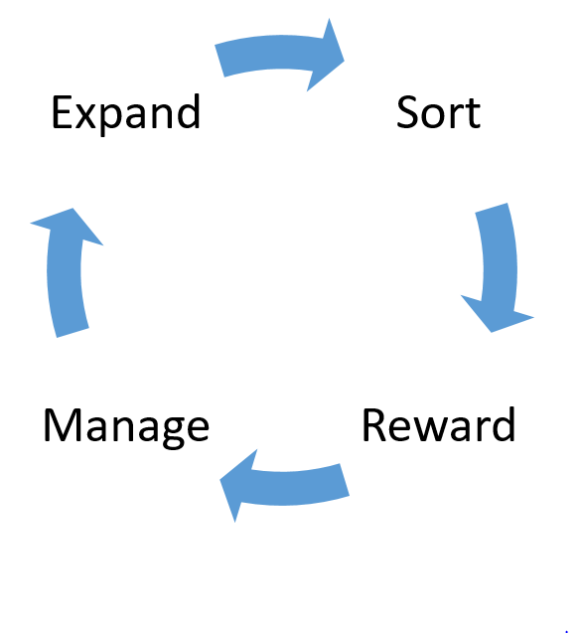**Game Loop:**

Expand: Players will be able to plant, build or place things onto their planet

Sort: Players will be able to zoom into sections of their planet in order to collect items, creatures, etc through the use of a sorting mechanic.

Reward: The player may receive rewards for collecting certain amounts of things which will allow them to unlock new items to place onto their planet.

Manage: Players will need to manage their planet as there will be some ‘upkeep’ involved. E.g. the player’s flowers may begin to wilt if not watered for a certain amount of time.

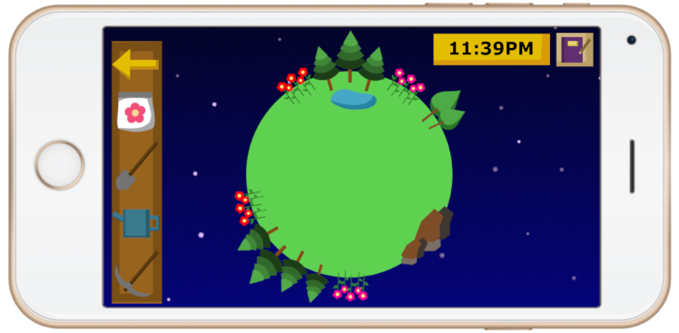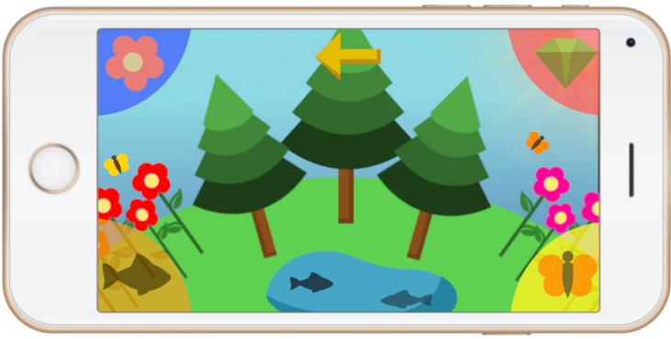**Features:**

The player will be able to see a zoomed out view of their entire planet or be able to zoom into individual sections which will allow them to collect items through a sorting mechanic.

The game will be based on real world time, with certain items/creatures only available at specific times of day. Growing plants and building objects may also require waiting real time until they are complete.

Players will need to manage and maintain certain aspects of their planet as planets may wither etc if not watered for long periods of time.

There will also be a journal the player can view which will show a list of all of the collectible items in the game. Once the player has collected one of an item, it will be displayed in the journal.

**Target Audience:**

Female, age 25-50

Casual gamers

Explorers and achievers (Bartle’s taxonomy of player types)

Our game will appeal to the specified target audience through the nurturing and decorating aspects of the game and through the art style.

As the game is for mobile, it will be ideal for casual gamers as it will be convenient for players to check in on their planet often and for short amounts of time.

Explorers will enjoy searching around the different areas of their planet and collecting/discovering new things.

Achievers will enjoy filling out their journal and completing the list of collectible items.

**Types of fun:**

Serious fun – relaxation, focus, play as therapy

Easy fun – exploration, imagination, curiosity

**MDA:**

|  |  |  |
| --- | --- | --- |
| **MECHANICS** | **DYNAMICS** | **AESTHETICS** |
| Sorting | Nurturing | Relaxation |
| Management | Exploration | Sense of achievement (fiero) |
|  | Collecting | Wonder and awe |
|  |  | Curiosity |

**Art Style:**

We want to maintain a simplistic, minimalistic art style with vibrant colours. The art will be fairly simple as the game is designed to be played on a mobile device, and if the players zoom out to see a full view of their planet we don’t want the screen to appear too cluttered and we want each object to stand out separately and be clearly visible.

The art in the game will change depending on the season and time of day.